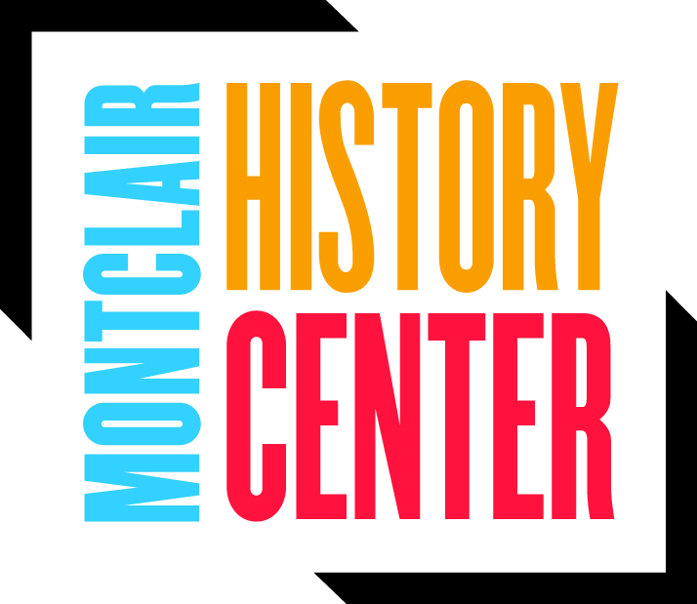
Membership Portal
- To access your membership portal you need to log in using the following link: https://app.donorview.com/6rPv You will then be directed to the following screen:
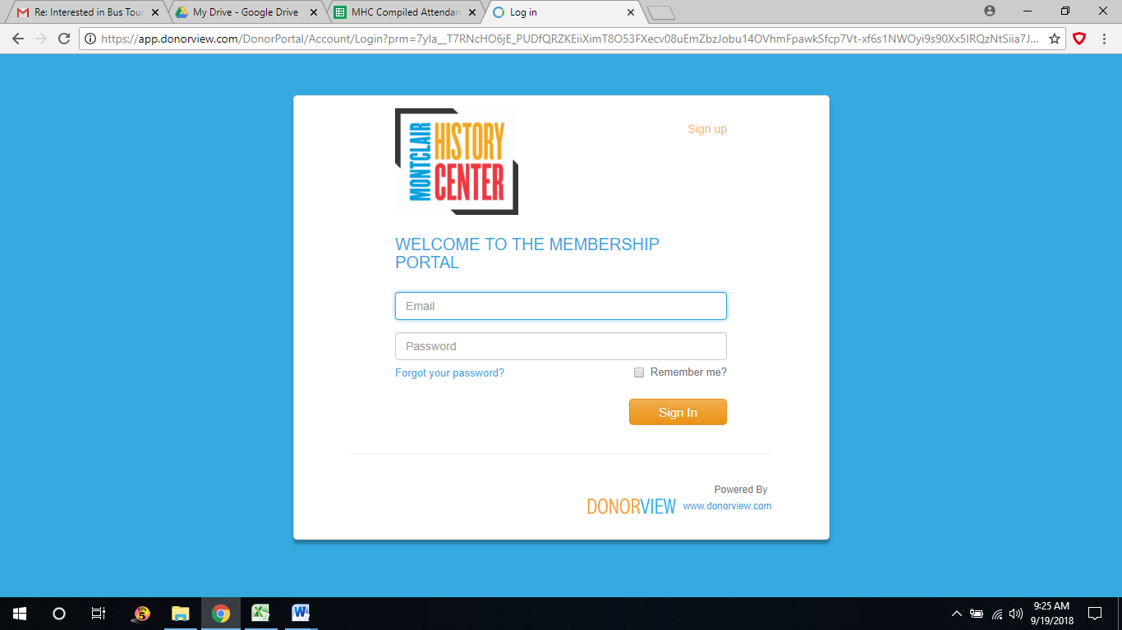
- If you have not yet created an account, please do so by clicking on the orange: “Sign up” button located at the top right of the screen.
- You should receive a confirmation code to your e-mail which will allow you to log into your membership portal using the e-mail and password you have created during the “Sign Up” process.
- Log into the membership portal using the log in information you created, upon doing so you should be directed to the following screen:
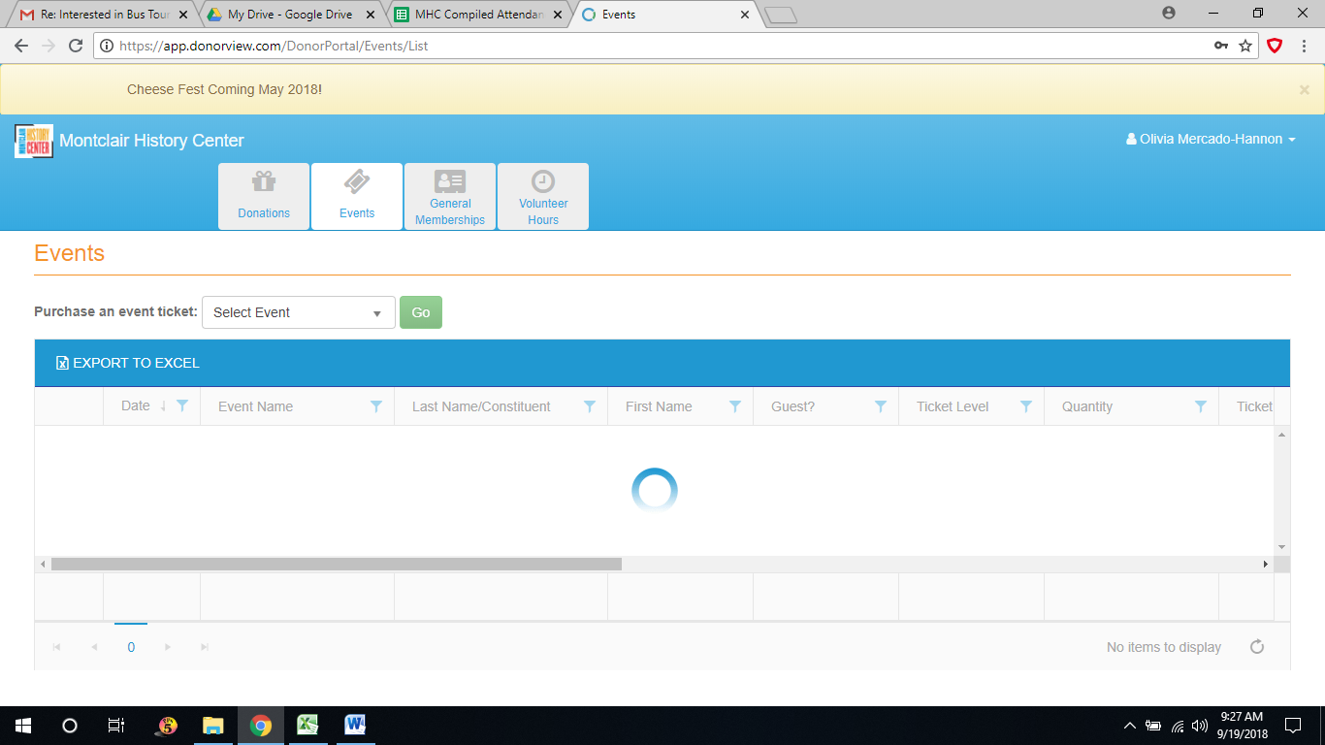
- Once in this screen you can select the “events tap” on the top, then select an event using the drop down arrow. Here you will be able to purchase tickets to any events offered at the Montclair History Center
- For any issues or concerns, please reach out the History Center at: 973-744-1796 and someone will be sure to assist you.

